Heating Instructions for Food Delivery

BOSCO STICKS
- Preheat the oven to 350ºF.
- Place the wrapped Bosco Stick on a baking sheet
- For a crispier crust, open one end of wrapper before baking
- If thawed, bake 9-10 minutes – If frozen, bake 16-17 minutes
- Let stand 2 minutes before serving

JTM HAMBURGER PATTY
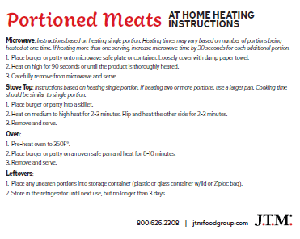
TACO AND BURRITO FILLINGS
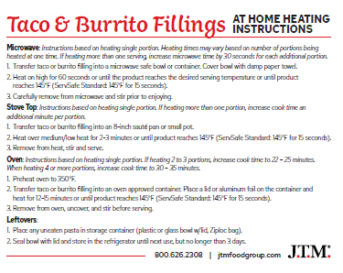

CHICKEN PATTY FOR SANDWICH
Cook from frozen state. Cook to a minimum internal temperature of 165 ºF.
- Conventional Oven: Bake at 400 ºF for 13-15 minutes
- Skillet method: Fry over medium high heat 2-3 minutes on each side.
Allergens: Milk, Wheat

MOZZARELLA CHEESE STICKS
Keep frozen until ready to prepare.
Microwaving is NOT recommended.
Due to differences in appliances and quantity prepared, cooking times may vary and require adjustment.
Caution: Product will be hot! Check product 1-2 minutes before indicated time. If cheese becomes visible, remove from heat.
- Preheat oven to 350 ºF
- Arrange product in a single layer on lined baking sheet.
- Bake for 9-10 minutes.
Contains: Milk, Wheat derived from bioengineering.

GRILLED CHEESE SANDWICH – INDIVIDUALLY WRAPPED
- Bake in 325° oven or microwave until wrapped sandwich to 160°
OR
- Using a non-stick skillet, over medium-heat, brown sandwich in margarine turning to brown each side until cheese is melted.
hot dogs
Please Choose a Cooking Method
- Grilling: Preheat grill. Grill hot dogs for 7-9 minutes, or until heated through, turning occasionally. When hot dog are done on the grill, remove all at once to avoid overcooking.
- Stove Top: Add hot dogs to saucepan of boiling water. Return to boil; cover. Remove from heat and let sit 7 minutes or until heated through.
- Microwave: Place hot dog on a paper towel. Microwave on HIGH for 15-20 seconds, or until heated through.
- Baking: Heat oven to 350. Line a cookie sheet with aluminum foil. Place hot dog(s) on cookie sheet. Bake for 10 minutes, or until heated through.
- Toaster Oven: Line toaster oven tray with aluminum foil. Heat oven to 350. Add 3-4 diagonal cuts on each hot dog and place on tray. Bake for 7-9 minutes, or until heated through, turning occasionally.

HOT DOG SAUCE
place sauce in a microwave safe container and reheat for about 15 seconds or until sauce is at least 165°.
CHICKEN FAJITA
Place in a heat-proof container and reheat for about 15 seconds or until sauce is at least 165°.
PEPPERONI PIZZA
Cook before eating.
- Cook from frozen state.
- Place pizza on a lightly greased baking sheet.
- Preheat oven to 400°.
- Bake for 21-24 minutes.
- Rotate pan halfway through cooking to prevent cheese from burning.
- Refrigerate or discard any uneaten portion.
For food safety and quality, cook before eating to an internal temperature of 165°.
Due to variances in oven temperatures, cooking time and temperature may require adjustment.
HAM & CHEESE CROISSANT
- Thaw and serve
- Keep under refrigeration until consumed.
- Eat within 2 days of thawing.

FROZEN CORN AND PEAS
- Place in a microwave safe container and heat for 15 seconds or until food reaches 165°.
- Season to taste.

BAKING POTATO
- Do NOT use foil in the microwave!
- Place potato on a heatproof plate and cook on high for 5 minutes.
- Test for doneness by pricking with knife or fork.
- Turn potato over and cook additional time needed until tender.
- Season to taste.

BABY BAKER POATOTES
Baking in Oven:
- Spray baking pan with nonstick cooking spray.
- Arrange frozen potatoes in a single layer.
- Bake at 450° for 25 minutes.
Microwaving:
- Place frozen potatoes in microwave safe dish
- Cover and microwave on high, stirring halfway through cooking time.
- Cook for 10 minutes.
CRISPY FRIES, SEASONED WEDGES
Baking
- Preheat oven to 425°
- Bake for 13-15 minutes, turning once for uniform cooking

POTATO SMILES, EMOJI POTATOES
For best results, cook from a frozen state using recommended time and temperature. Always cook to a light golden color. Do not overcook.
Deep Fryer:
- Preheat oil to 350°
- Fill basket 1/3full with frozen product
Baking
- Preheat oven to 425°
- Spread product evenly on a shallow baking pan.
- Bake for 9-13 minutes, turning once for uniform cooking.
INDIVIDUALLY WRAPPED CHEESE PIZZA
For best results, cook from a frozen state.
Baking:
- Preheat oven to 400°.
- Bake for 24-26 minutes.
Microwaving:
- Unwrap pizza.
- Cook 2-3 minutes or until pizza reaches 160°.
Note: Due to variances in ovens and the number of pizza being cooked, cooking time and temperature may require adjustments.

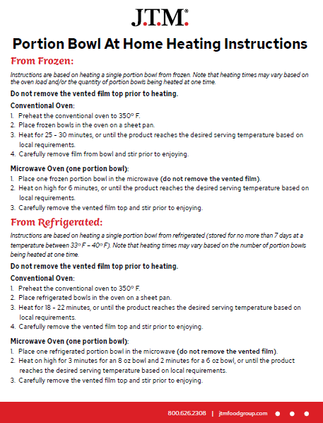

GOLD KIST FOODS
Chicken Strips: 6216 Gold Kist WG Breaded Chicken Strips Heating Instructions from Frozen: Conventional Oven: Preheat oven to 350°F. Place frozen chicken pieces in a single layer in an ungreased baking pan. Bake uncovered for 30 minutes. Convection oven: Preheat oven to 350°F. Place frozen chicken pieces in a single layer in an ungreased baking pan. Bake uncovered for 12 minutes. Insert a meat thermometer into the thickest portion of the product. Continue heating until the internal temperature reaches 165°F. Appliances vary adjust heat times accordingly. Allergens: wheat

Chicken Nuggets: 6116 Gold Kist WG Breaded Chicken Bites Heating Instructions from Frozen: Conventional Oven: Preheat oven to 350°F. Place frozen chicken pieces in a single layer in an ungreased baking pan. Bake uncovered for 30 minutes. Convection oven: Preheat oven to 350°F. Place frozen chicken pieces in a single layer in an ungreased baking pan. Bake uncovered for 14 minutes. Insert a meat thermometer into the thickest portion of the product. Continue heating until the internal temperature reaches 165°F. Appliances vary adjust heat times accordingly. Allergens: wheat

7803 Pierce WG Breaded Drumsticks Heating Instructions from Frozen: Conventional Oven: Preheat oven to 350°F. Place frozen chicken pieces in a single layer in an ungreased baking pan. Bake uncovered for 40 minutes. Convection oven: Preheat oven to 350°F. Place frozen chicken pieces in a single layer in an ungreased baking pan. Bake uncovered for 25 minutes. Insert a meat thermometer into the thickest portion of the product. Continue heating until the internal temperature reaches 165°F. Appliances vary adjust heat times accordingly. Allergens: wheat

7805 Pierce Oven Roasted Wings Heating Instructions from Frozen: Conventional Oven: Preheat oven to 350°F. Place frozen chicken pieces in a single layer in an ungreased baking pan. Bake uncovered for 38 minutes. Convection oven: Preheat oven to 350°F. Place frozen chicken pieces in a single layer in an ungreased baking pan. Bake uncovered for 20 minutes. Insert a meat thermometer into the thickest portion of the product. Continue heating until the internal temperature reaches 165°F. Appliances vary adjust heat times accordingly. Allergens: n/

Popcorn Chicken: 110452 Gold Kist WG Breaded Chicken Smackers Heating Instructions from Frozen: Conventional Oven: Preheat oven to 350°F. Place frozen chicken pieces in a single layer in an ungreased baking pan. Bake uncovered for 30 minutes. Convection oven: Preheat oven to 350°F. Place frozen chicken pieces in a single layer in an ungreased baking pan. Bake uncovered for 14 minutes. Insert a meat thermometer into the thickest portion of the product. Continue heating until the internal temperature reaches 165°F. Appliances vary adjust heat times accordingly. Allergens: milk, soy, wheat

