Google Forms
From Waffle Click on Form
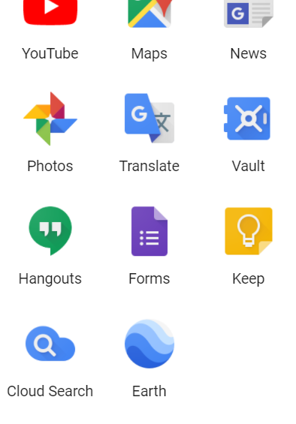
How to Create a Google Form
- Start a new form.
- Title Form
- Choose question type in the gray drop down box on the right mid-screen.
- Type question in the untitled question line.
- For multiple choice begin to add options. (Simply enter after each question)
- Practice using the Paragraph and Short Answer Responses
How to Convert Responses to an Excel Sheet
- At the top of the form there are two buttons, “Questions” and “Responses”.
- Click on Responses.
- Then click the green sheets icon.
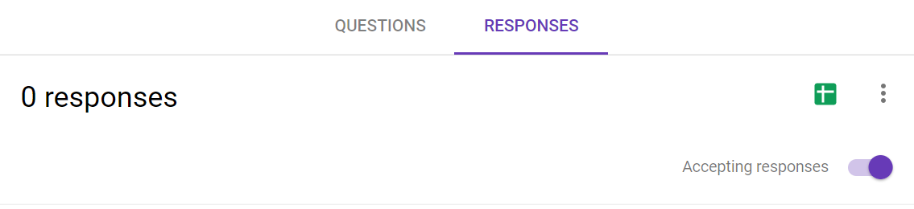
How to Convert the form to a Quiz
- Click on the gear in the top right corner.

- Click on the Quiz tab and make the appropriate choices. Be sure to save selections.

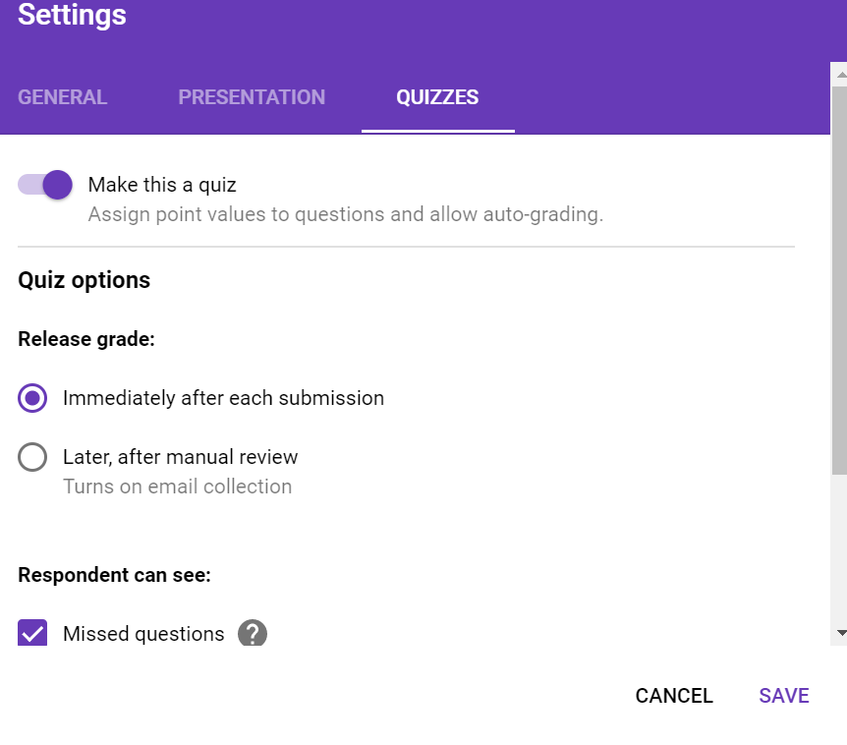
How to limit responses and editing.

- Choose the same gear button at the top right. This time click on general instead of quizzes.

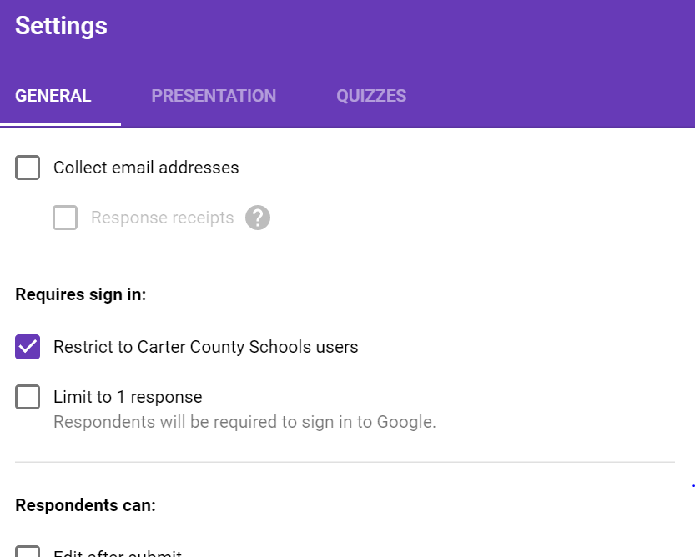
- From here, you can limit students to one response and either allow for editing after submission or block editing after submission. Be sure to save.

