Algebra 1 Unit 5 Systems of Equations and Inequalities
Practice Packet:  Algebraic Solutions To Linear Systems 5 Pack  Algebraic Solutions to Simultaneous Equations 5 Pack  Create Equations with 2 or More Variables  Create Equations with 2 or More Variables Matching  Linear Systems 5 Pack  Solve Systems of Equations Matching  Solve Systems of Equations  Solving Linear Equations and Inequalities  Solving Linear Equations and Inequalities Matching  Solving Linear Inequalities 5 Pack | Writing Task:  Throwing a Ball Task  Pairs of Numbers Task
Game/Activity:  Elimination Game—Can set this to different levels and it has a “teach me” function  https://www.mangahigh.com/en-us/math_games/algebra/systems_of_equations_/solve_systems_of_equations_-_elimination_method  Substitution Memory Game | Technology:  Solve equations and inequalities—Jeopardy Game  https://www.superteachertools.us/jeopardyx/jeopardy-review-game.php?gamefile=305786#.V5jCQctTHcs  Scroll Down to HSA.REI.B on Khan Academy and use all the resources for this standard.  https://www.khanacademy.org/commoncore/grade-HSA-A-REI#HSA-REI.B.3
Art/Music/Drama/etc. :

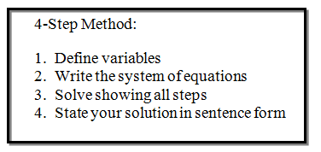

Create a song, rap, model, flow chart, skit, etc. where you represent the four step method for solving systems of equations. Be prepared to demonstrate or perform your project to a small group.

