Concept and Mind Mapping

A concept or mind map is a graphical way to represent ideas and concepts. It is a visual thinking tool that helps structuring information, helping you to better analyze, comprehend, synthesize, recall and generate new ideas.
Just as in every great idea, its power lies in its simplicity.

In a mind map, as opposed to traditional note taking or a linear text, information is structured in a way that resembles much more closely how your brain actually works. Since it is an activity that is both analytical and artistic, it engages your brain in a much, much richer way, helping in all its cognitive functions. And, best of all, it is fun!
So, how does a mind map look like? Better than explaining is showing you an example.
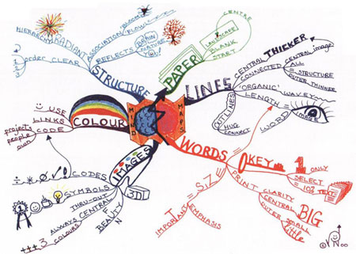
(click for larger image)
This is a mind map about mind mapping itself. It presents, in a visual way, the core elements and techniques on how to draw mind maps.

Benefits and Uses
Basically, mind mapping avoids dull, linear thinking, jogging your creativity and making note taking fun again.
How can we use a concept or mind map?
- Note taking
- Brainstorming (individually or in groups)
- Problem solving
- Studying and memorization
- Planning
- Researching and consolidating information from multiple sources
- Presenting information
- Gaining insight on complex subjects
- Jogging your creativity

How to Draw a Mind Map
Drawing a mind map is as simple as 1-2-3:
- Start in the middle of a blank page, writing or drawing the idea you intend to develop. I would suggest that you use the page in landscape orientation.
- Develop the related subtopics around this central topic, connecting each of them to the center with a line.
- Repeat the same process for the subtopics, generating lower-level subtopics as you see fit, connecting each of those to the corresponding subtopic.
Some more recommendations:
- Use colors, drawings and symbols copiously. Be as visual as you can, and your brain will thank you. I’ve met many people who don’t even try, with the excuse they’re "not artists". Don’t let that keep you from trying it out!.
- Keep the topics labels as short as possible, keeping them to a single word – or, better yet, to only a picture. Especially in your first mind maps, the temptation to write a complete phrase is enormous, but always look for opportunities to shorten it to a single word or figure – your mind map will be much more effective that way.
- Vary text size, color and alignment. Vary the thickness and length of the lines. Provide as many visual cues as you can to emphasize important points. Every little bit helps engaging your brain.

