APPENDIX N

INSTRUCTIONAL SPECIALIST PRE-CONFERENCE FORM Electronic Forms Provided at www.cartercountyschools.org
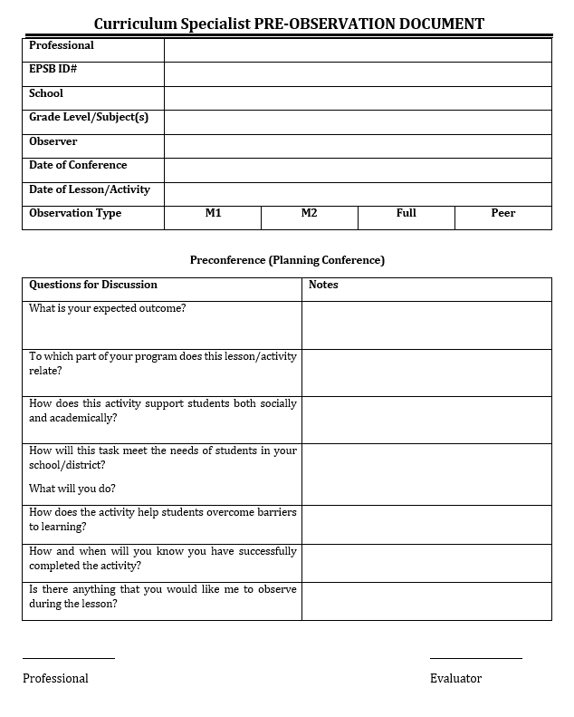

59

